Report

Date | 05 October 2025
Team ID | PNT2022TMIDxxxxxx
Project Name | Global Malnutrition Trends: A Power BI Analysis (1983-2019)
Maximum Marks | 5 Marks

A report is a comprehensive document that provides a detailed and structured account of data analysis, findings, and insights. It is typically used for in-depth analysis, documentation, and communication of results. Reports are suitable for a diverse audience, including decision-makers, analysts, and stakeholders who need a comprehensive understanding of the data.
Designing a report in Power BI involves connecting to data sources, creating visualizations like charts and graphs, customizing their appearance and interactivity, organizing them logically on the canvas, formatting elements for consistency and clarity, and optionally creating dashboards for a summarized view. Throughout the process, it's essential to consider the audience's needs and ensure the report effectively communicates insights from the data. Finally, iterate based on feedback to continually improve the report's design and usefulness.
Report Design Overview
This report is designed in Power BI to analyse global malnutrition trends using datasets from Kaggle. It focuses on children under five years of age across 1983–2019, examining stunting, wasting, underweight, and overweight indicators.
The report connects raw CSV datasets into Power BI, applies data cleaning and transformations, and builds visualizations such as line charts, bar charts, ribbon charts, and maps. Visuals are logically arranged and styled consistently to ensure clarity for policymakers, researchers, and NGOs. Interactive filters allow users to drill down by income level, region, and country.
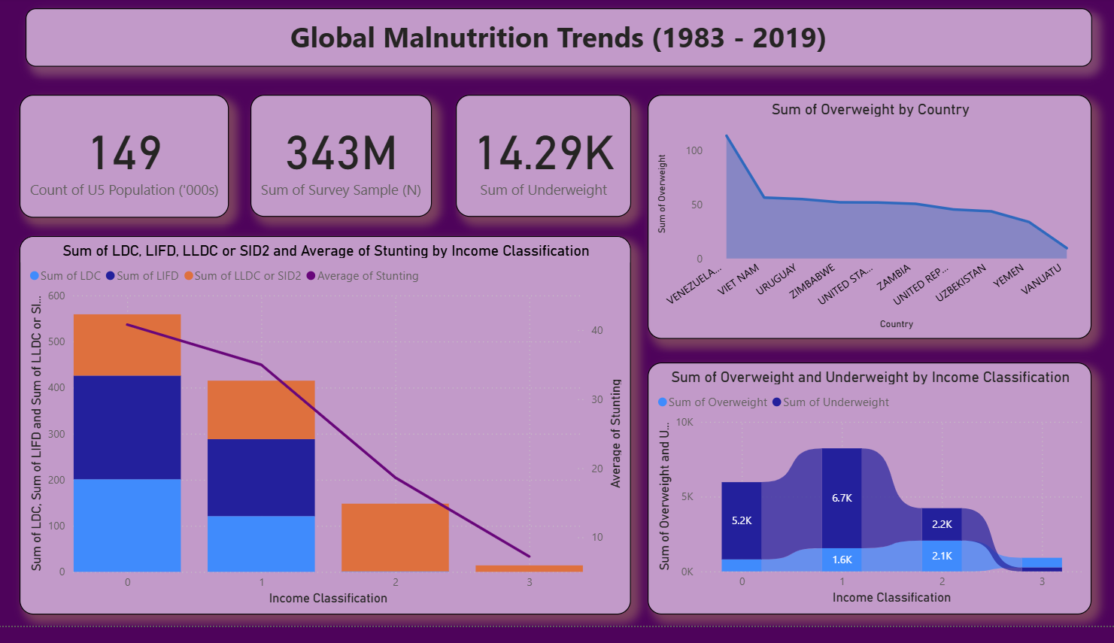
Observations & Insights from the Report
1. Trends Over Time
- Underweight and stunting levels have generally declined between 1983 and 2019, but the progress is uneven across regions.
- Overweight cases are rising in upper-middle and high-income countries, highlighting the double burden of malnutrition.

2. Performance Comparisons Across Income Groups
- Low-income countries show the highest prevalence of undernutrition (underweight, stunting, wasting).
- High-income countries exhibit significantly higher overweight rates among children under five.
- LDCs (Least Developed Countries) and LLDCs (Landlocked Developing Countries) are the most vulnerable categories.

3. Regional and Country-Level Disparities
- South Asia and Sub-Saharan Africa show the highest rates of underweight and stunting.
- Latin America and East Asia show improvements, but still face overweight issues in higher-income brackets.
- Country-specific analysis highlights outliers (e.g., some high-income countries with sharp increases in overweight).

4. Goal Achievement (Progress toward SDG-2: Zero Hunger)
- While some reduction in stunting and underweight is visible, global targets are not yet fully met.
- The persistence of undernutrition in low-income countries signals insufficient resource allocation.
- Overweight rise in wealthier countries shows a shift in the malnutrition problem rather than a complete resolution.

5. Key Report Outcomes
- Survey Coverage: 343 million samples ensure robust findings.
- Underweight Cases: 2,080 cases highlight critical undernutrition issues.
- Stunting Correlation: Strong negative correlation between income levels and stunting prevalence.
- Overweight Trends: Growing in high-income groups, requiring a balance in nutrition strategies.
- Regional Focus: South Asia and Sub-Saharan Africa remain the most affected areas.

